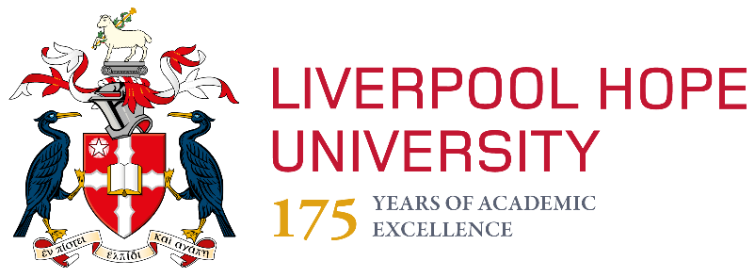
Liverpool Hope University Social Media Policy for Staff

Responsibility for Policy:
Relevant to: All Liverpool Hope Staff and Academic Partnerships
Approved by:
Responsibility for Document Review: Head of External Relations (on behalf of …)
Date introduced:
Date(s) modified:
Next Review Date:

Related policies and documents
List here any internal policies or documents that are relevant to this policy e.g.
- Staff Handbook
- Code of Conduct for Staff

Using Social Media
Our students are prolific users of social media and so, when possible, we should be too.
It is a good way to engage with students, prospective and current, and stakeholders/wider public.
This policy has been designed to give staff clear guidelines as to what Liverpool Hope University expects of them when accessing and using social media websites.
The absence of, or lack of, explicit reference to a specific website or platform does not limit the extent of the application of this policy. Where no policy guidelines exist, employees should use their professional judgement and take the most appropriate action. Consult your line manager and/or the External Relations team if you need advice (e-mail: press@hope.ac.uk or finnign@hope.ac.uk).

Guidance for official Liverpool Hope accounts
Liverpool Hope operate a number of social media accounts for the promotion of activities and events as to communicate with students/staff/stakeholders and the wider public.
Setting up official accounts
- An official Hope social media account may only be set up with consent from the Head/Director of your area. A copy of this consent, together with a brief summary of the account’s purpose and a list of staff who will maintain it should be created and shared with External Relations.
- Log-in details should be shared with Hope’s social media officer (finnign@hope.ac.uk)
- Accounts should be consistent, with names starting with Liverpool Hope (e.g. Liverpool Hope L&T) and NOT Hope University or LHU. Seek advice form the social media officer on use of correct logos and appropriate banners. The design team in External Relations can provide these by logging a job with them. For more details see our style guide.
- Do not set up an account if you do not have the time to update and monitor it regularly. A neglected social media presence will reflect poorly on the University.

Use of official accounts
The following outlines the limits of use:
- Only authorised staff may use these accounts to post online and access to the account should be limited and monitored.
- Users should be aware at all times that content reflects on the University’s reputation.
- All information published on the internet must comply with Liverpool Hope confidentiality and data protection policies.
- Copyright laws must be respected, with references or sources cited appropriately.
- Encourage interaction with your followers, respond to comments and questions as much as possible.
- Deal with any reasonable negative feedback as quickly as possible and follow up problems positively and honestly. Accept that some people use social media (particularly Twitter) to vent frustration at things we cannot be responsible for or respond to constructively. Using the direct messaging function on Twitter can often be a better way to solve a problem in some cases but do not write anything in a DM you would not write in a tweet. If you are uncertain contact External Relations/our Social Media officer.
- Any employee who becomes aware of social networking activity that would be deemed offensive or objectionable should tell their line manager as soon as possible. This might include others using the Liverpool Hope name, logo or brand in a manner that might mislead or confuse people in relation to its brand or business affiliation with the University.
- When possible use a generic departmental e-mail address to register social media accounts. If an individual address is used ensure access details are logged in case that person leaves. If the person who set up the account leaves, change the passwords for security purposes.

All staff using official accounts must adhere to the above guidelines.
Guidance for personal use
If you have your own personal social media profile(s), you should make sure that others cannot access any content, media or information from the profile that:
- You are not happy for others to access.
- Would undermine your position in a professional organisation.
- Could damage the reputation of the University.
- If using social media for academic purposes, the University’s branding should not be used. A clear statement should also be incorporated into your profile to say that views expressed are your own and do not reflect those of the University.

Using social media sites
As a staff member, when using social media sites you should:
- If using social media for academic purposes, the University’s branding should not be used. In this case a clear statement should also be incorporated into your profile to say that views expressed are your own and do not reflect those of the University.
- Make sure your personal accounts do not contain anything to suggest you are acting in an official capacity (e.g. using LivHope in the profile name).
- Obtain prior consent from External Relations before using Liverpool Hope branding, logos and trademarks.
- Ensure information published on the internet complies with Liverpool Hope confidentiality and data protection policies.
- Remember you are legally liable for anything you post online.
- Remember that you are an ambassador for Liverpool Hope University and your actions captured via images, video, posts or comments can reflect on the University.
- Ensure you are always respectful towards
- Liverpool Hope University
- Other members of staff
- Students
- Parents and families
- Stakeholders
- Other agencies and partners

Reporting concerns
If you have concerns relating to social media you should contact External Relations advice at press@hope.ac.uk or finnign@hope.ac.uk
This may include issues such as your portrayal by others or damage to your reputation, the behaviour of Liverpool Hope colleagues or students, or evidence of bullying or harassment of members of the Liverpool Hope community.

