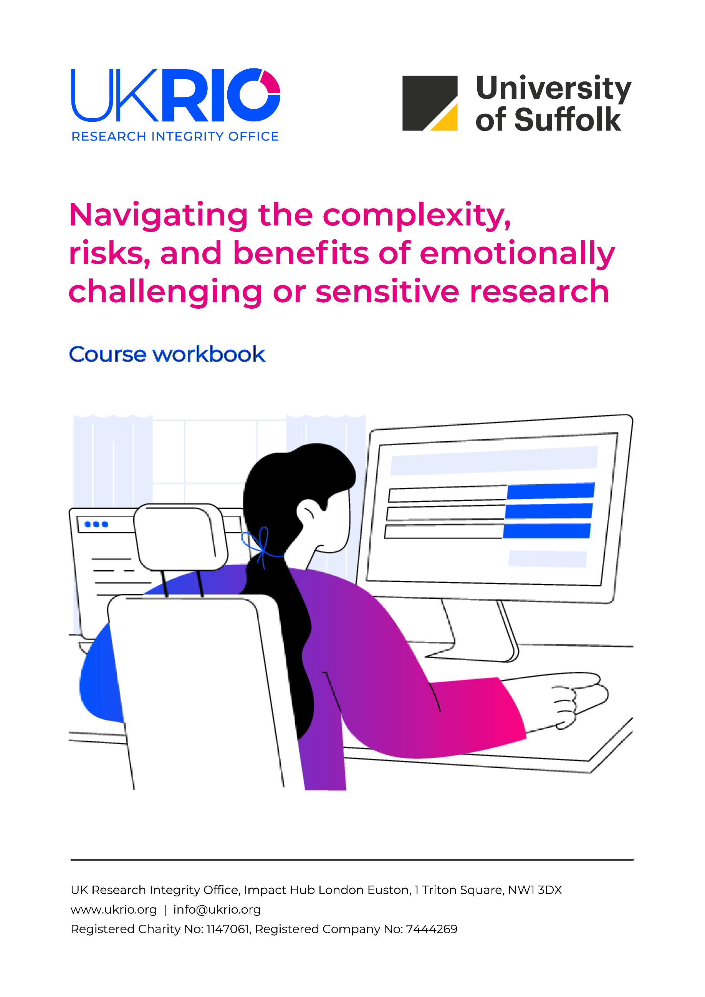



About UKRIO 1
The course workbook 2
Navigating the complexity, risks, and benefits of emotionally challenging or sensitive research 3
Learning objectives 3
Reflective activity 3
LO1: Define emotionally challenging or sensitive research 3
Pause and reflect 1.1 3
Further reading and resources 4
LO2: Explain the complexities, risks, and benefits of emotionally challenging or sensitive research 4
Pause and reflect 2.1 4
LO3: Describe and explain positionality in relation to emotionally challenging or sensitive research 5
Pause and reflect 3.1 5
Further reading and resources 6
LO4: Critically assess the challenges posed by different types of data (primary and secondary) in emotionally challenging or sensitive research 7
Pause and reflect 4.1 7
Further reading and resources 8
More from UKRIO 11

The UK Research Integrity Office (UKRIO) is an independent charity established in 2006. UKRIO’s vision is that through our activities, the UK research community is supported to produce work of the highest integrity, quality, and efficacy.
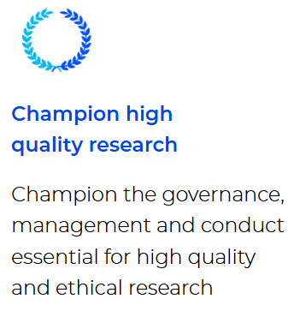
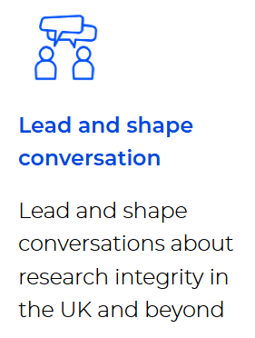
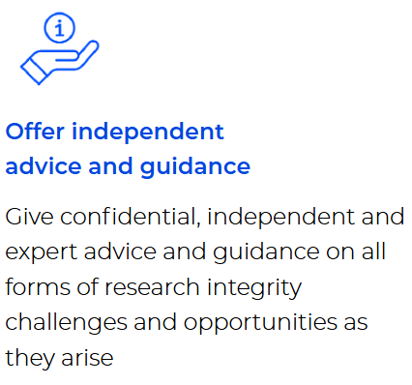
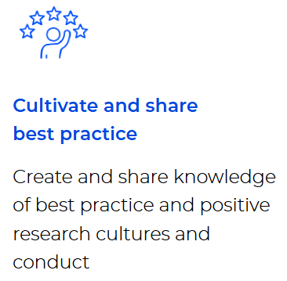
- Advisory Service: https://ukrio.org/our-work/get-advice-from-ukrio/
- Expert webinar series: https://ukrio.org/events/expert-webinar-series/
- Resources: https://ukrio.org/resources/
- Subscribers: https://ukrio.org/our-work/our-subscribers/


About UKRIO

The course workbook



This is your private course workbook for UKRIO’s online training course, Navigating the complexity, risks, and benefits of emotionally challenging or sensitive research.
Save this document on your personal device – this document will not be shared online, and other learners cannot access your workbook.
Use this workbook to type your notes and answers to the reflective questions in the course. To help you organise your notes, the activities are replicated here for each learning objective.
All further reading and resources for each learning objective are also included in this document.

Disclaimer on external resources and third-party content
This course includes references and links (including hyperlinks) to external resources, tools, and materials intended to support researchers in understanding research ethics. These signposted resources are provided for convenience and are not intended to be comprehensive.
Please note that not all references are open access. Inclusion of any external link or reference does not imply endorsement or approval by UKRIO of the linked website, its operator, or its content. UKRIO is not responsible for the accuracy, content, or quality of third-party materials, nor for any websites outside of www.ukrio.org.
Researchers are encouraged to exercise professional judgement when engaging with external resources and the content provided within this course. It is important to assess the relevance, reliability, and suitability of each resource and piece of content within the context of their specific research. The information presented here is intended for educational purposes only and should not be considered a substitute for legal advice from appropriately qualified professionals. UKRIO accepts no liability for any loss or damage caused or occasioned as a result of the information provided.

Navigating the complexity, risks, and benefits of emotionally challenging or sensitive research
This course examines emotionally challenging and sensitive research, focusing on its definitions, complexities, and the risks and benefits for both participants and researchers. You will reflect on key considerations such as vulnerability, context, positionality, and power dynamics, while exploring how your own identity and experiences shape the research process. The course also highlights the distinct ethical, emotional, and methodological challenges of working with primary and secondary data.

Learning objectives
- LO1: Define emotionally challenging or sensitive research
- LO2: Explain the complexities, risks, and benefits of emotionally challenging or
sensitive research
- LO3: Describe and explain positionality in relation to emotionally challenging or
sensitive research
- LO4: Critically assess the challenges posed by different types of data (primary and
secondary) in emotionally challenging or sensitive research

Reflective activity

LO1: Define emotionally challenging or sensitive research

Pause and reflect 1.1
Take a moment to reflect on your own perspectives and experiences relating to emotionally challenging or sensitive research.
Question | Your answer
What does emotionally challenging or sensitive research mean to you? | Click or tap here to enter text.
Are there research topics you think are intrinsically emotive or sensitive? | Click or tap here to enter text.
What is it about these topics that makes them emotionally challenging? | Click or tap here to enter text.
What are some of the potential emotional challenges or sensitivities associated with your own research or your research discipline? | Click or tap here to enter text.

Further reading and resources
Emotional challenges:
- Mallon S, Elliott I. (2019). The Emotional Risks of Turning Stories into Data: An Exploration of the Experiences of Qualitative Researchers Working on Sensitive Topics. Societies. 9:62. https://doi.org/10.3390/soc9030062

LO2: Explain the complexities, risks, and benefits of emotionally challenging or sensitive research

Pause and reflect 2.1
Consider the following statements and associated questions.
The decisions you make within a research project have consequences, including both intended and unintended outcomes.
Have you reflected on the potential consequences of your research decisions, including outcomes you might anticipate as well as those that could be unexpected?
Be aware that when we hold senior roles - such as in a workplace or school (e.g., as a teacher, a senior colleague) power dynamics exist, and these need to be acknowledged and carefully considered.
Question | Your answer
Do you understand power dynamics and how they can impact emotionally challenging or sensitive research? | Click or tap here to enter text.
Thinking about your own research, where might there be power dynamics and sensitivities to consider? | Click or tap here to enter text.
Have you identified the potential risks and complexities of your project, both for yourself as the researcher and your participants? | Click or tap here to enter text.

LO3: Describe and explain positionality in relation to emotionally challenging or sensitive research

Pause and reflect 3.1
Your positionality and reflexivity will be complex and context dependent. Identifying the right answer in a given situation is often grounded in specific circumstances, needs, and relationships, requiring researchers to reflect on, interpret, and embody overarching ethical principles, rather than adhering to universal rules.
Pause and reflect on the following questions:
Question | Your answer
What beliefs, values, and assumptions do you bring to your research, or when engaging with research from your subject area? | Click or tap here to enter text.
How are these shaped by your personal characteristics and experiences? | Click or tap here to enter text.
How have your own standpoints and experiences affected your interactions and relationships with research participants in the past? How would they shape the potential risks and benefits of the research? | Click or tap here to enter text.

Pause and reflect 3.2
Scenario: Researcher wellbeing
A researcher is undertaking a project investigating the use of stereotypes in police interviews. They have spent a great deal of time transcribing police interviews, analysing what was said and how the interviews were conducted. This involved becoming immersed in the interviewees’ evident distress and their stories, as well as the interviewers’ sometimes poor treatment of and disbelief in them.
Reflect on the following questions.
Question | Your answer
How might this experience impact the researcher? | Click or tap here to enter text.
What could the researcher do to mitigate the negative impacts of this experience? | Click or tap here to enter text.

Further reading and resources
Further reading on ontology, epistemology and axiology:
- Pretorius, L. (2024). Demystifying research paradigms: Navigating ontology, epistemology, and axiology in research. The Qualitative Report, 29(10), 2698-2715. https://doi.org/10.46743/2160-3715/2024.7632
Further reading on positionality:
- Chavez, C., 2008. Conceptualizing from the inside: Advantages, complications, and demands on insider positionality. The qualitative report, 13(3), 474-494. https://doi.org/10.46743/2160-3715/2008.1589
Marginalisation:
- Crenshaw, K., 1991. Race, gender, and sexual harassment. s. Cal. l. Rev., 65, p.1467. https://scholarship.law.columbia.edu/faculty_scholarship/2867/
- Mowat, J.G., 2015. Towards a new conceptualisation of marginalisation. European Educational Research Journal, 14(5), pp.454-476. https://doi.org/10.1177/1474904115589864

Vulnerability:
- UKRI: Research with potentially vulnerable people. https://www.ukri.org/councils/esrc/guidance-for-applicants/research-ethics-guidance/research-with-potentially-vulnerable-people/
Trauma:
- Jaffe, A.E., DiLillo, D., Hoffman, L., Haikalis, M., & Dykstra, R.E. (2015). Does it hurt to ask? A meta-analysis of participant reactions to trauma research. Clin Psychol Rev. 40:40-56. https://doi.org/10.1016/j.cpr.2015.05.004
- Silverio, S. A., Sheen, K. S., Bramante, A., Knighting, K., Koops, T. U., Montgomery, E., November, L., Soulsby, L. K., Stevenson, J. H., Watkins, M., Easter, A., & Sandall, J. (2022). Sensitive, Challenging, and Difficult Topics: Experiences and Practical Considerations for Qualitative Researchers. International Journal of Qualitative Methods, 21. https://doi.org/10.1177/16094069221124739 (Original work published 2022)
- Sage Research Methods Community, Self-Care and Well-being for Researchers Studying Sensitive Issues (2022): https://researchmethodscommunity.sagepub.com/blog/self-care-for-researchers-studying-sensitive-issues
- University of St Andrews: Trauma-informed research and distress: https://www.st-andrews.ac.uk/research/integrity-ethics/humans/ethical-guidance/distress-/
- UK Trauma Council, 2025: https://uktraumacouncil.org/trauma/trauma?cn-reloaded=1

LO4: Critically assess the challenges posed by different types of data (primary and secondary) in emotionally challenging or sensitive research

Pause and reflect 4.1
Take a moment to consider how working with primary and secondary data might affect you and others – reflecting on potential emotional, ethical, and moral challenges.
Questions to consider:
Question | Your answer
Do you have a clear understanding of what primary and secondary data are? | Click or tap here to enter text.
Reflecting on your data collection method, do you anticipate any challenges from primary or secondary sources and/or potential for emotional or moral injury? | Click or tap here to enter text.
How will you mitigate the potential emotional impacts caused by the data you are working with? | Click or tap here to enter text.
Do you have contingency plans in place if you or any participant becomes distressed during the research? Do you know who you would contact if you needed support? | Click or tap here to enter text.

Further reading and resources
Further reading related to this course:
- Brown, V.B. (2017). Through a trauma lens: Transforming health and behavioral health systems. Routledge. https://doi.org/10.4324/9781315626109
- Brown, K. (2011) 'Vulnerability': Handle with Care, Ethics and Social Welfare, 5:3, 313-321. https://doi.org/10.1080/17496535.2011.597165
- Chavez, C., 2008. Conceptualizing from the inside: Advantages, complications, and demands on insider positionality. The qualitative report, 13(3), 474-494. https://doi.org/10.46743/2160-3715/2008.1589
- Crenshaw, K., 1991. Race, gender, and sexual harassment. s. Cal. l. Rev., 65, p.1467.
- Dickson-Swift, V., James, E.L., Kippen, S. and Liamputtong, P., 2007. Doing sensitive research: what challenges do qualitative researchers face?. Qualitative research, 7(3), pp.327-353. https://doi.org/10.1177/1468794107078515
- Isobel, S., 2021. Trauma-informed qualitative research: Some methodological and practical considerations. International journal of mental health nursing, 30, pp.1456-1469. https://doi.org/10.1111/inm.12914
- Jaffe, A.E., DiLillo, D., Hoffman, L., Haikalis, M. and Dykstra, R.E., 2015. Does it hurt to ask? A meta-analysis of participant reactions to trauma research. Clinical psychology review, 40, pp.40-56. https://doi.org/10.1016/j.cpr.2015.05.004
- Tebes, J.K., Champine, R.B., Matlin, S.L. and Strambler, M.J., 2019. Population health and trauma-informed practice: Implications for programs, systems, and policies. American Journal of Community Psychology, 64(3-4), pp.494-508. https://doi.org/10.1002/ajcp.12382
- Lee, R.M. and Renzetti, C.M., 1990. The problems of researching sensitive topics: An overview and introduction. American behavioral scientist, 33(5), pp.510-528. https://doi.org/10.1177/0002764290033005002
- Mallon, S., & Elliott, I. (2021). What is 'sensitive' about sensitive research? The sensitive researchers' perspective. International Journal of Social Research Methodology, 24(5), 523-535. https://doi.org/10.1080/13645579.2020.1857966
- Michalopoulos, L.M., Meinhart, M., Yung, J., Barton, S.M., Wang, X., Chakrabarti, U., Ritchey, M., Haroz, E., Joseph, N., Bass, J. and Bolton, P., 2020. Global posttrauma symptoms: A systematic review of qualitative literature. Trauma, Violence, & Abuse, 21(2), pp.406-420. https://doi.org/10.1177/1524838018772293
- Mowat, J.G., 2015. Towards a new conceptualisation of marginalisation. European Educational Research Journal, 14(5), pp.454-476. https://doi.org/10.1177/1474904115589864
- Rice, Carla. "Imagining the other? Ethical challenges of researching and writing women's embodied lives." Feminism & Psychology 19.2 (2009): 245-266. https://doi.org/10.1177/0959353509102222
- US Department of Health and Human Services, 2014. SAMHSA's concept of trauma and guidance for a trauma-informed approach. https://coresonline.org/sites/default/files/documents/samhsas_concept_of_trauma_and_guidance_for_a_trauma-informed_approach.pdf
- Vickers, E.L., 2019. Unexpected trauma in oral interviewing. The Oral History Review, 46(1), pp.134-141. https://doi.org/10.1093/ohr/ohy099
- Voith, L.A., Hamler, T., Francis, M.W., Lee, H. and Korsch-Williams, A., 2020. Using a trauma-informed, socially just research framework with marginalized populations: Practices and barriers to implementation. Social Work Research, 44(3), pp.169-181. https://doi.org/10.1093/swr/svaa013

Further reading on researcher wellbeing:
The resources below are compiled from GW4 R WELL (Researcher Wellbeing Evidence and Learning Lab): https://gw4.ac.uk/community/gw4-r-well-researcher-wellbeing-evidence-and-learning-lab/
- Quick tips if you are writing a grant application. https://www.researchgate.net/publication/380317053_Quick_tips_on_addressing_researcher_wellbeing_and_emotionally_challenging_topics_for_if_you_are_writing_a_grant_application
- Researcher Wellbeing Plan Guidance. https://www.researchgate.net/publication/380317446_Researcher_Wellbeing_Plan_Guidance
- Researcher Wellbeing Plan Template. https://www.researchgate.net/publication/380317302_Researcher_Wellbeing_Plan_Template_C
- Clinical supervisors who specialise in secondary trauma. https://www.researchgate.net/publication/380317573_Clinical_supervisors_who_specialise_in_secondary_trauma
- Example costs to add into grant applications. https://www.researchgate.net/publication/380317576_Example_costs_for_possible_service_package_within_the_Researcher_Wellbeing_Plan
- Guidance for what to do if a researcher/you get(s) distressed. https://www.researchgate.net/publication/380374975_Guidance_on_what_to_do_if_a_researcher_gets_distressed_during_emotionally_challenging_research
- Wellbeing guidance for researchers, teams and supervisors: gold, silver and bronze. https://www.researchgate.net/publication/380317102_Wellbeing_guidance_for_researchers_teams_and_supervisors_gold_silver_and_bronze_standards
- Guidance for institutional support of emotionally challenging research (funders and employers). https://www.researchgate.net/publication/380317583_Guidance_for_institutional_support_of_emotionally_challenging_research_funders_and_employers
- Risk assessment guidance for emotionally challenging research. https://www.researchgate.net/publication/380317406_Risk_assessment_guidance_for_emotionally_challenging_research
- Guidance for researchers if participants experience mild or moderate distress. https://www.researchgate.net/publication/380317624_Guidance_for_researchers_if_participants_experience_mild_or_moderate_distress
- Guidance for researchers if participants are at risk of serious harm. https://www.researchgate.net/publication/380317620_Guidance_for_researchers_if_participants_are_at_risk_of_serious_harm

Further reading on gender-based violence research:
- WHO. Ethical and safety recommendations for researching, documenting and monitoring sexual violence in emergencies. https://www.who.int/publications/i/item/9789241595681
- Global Women's Institute. Gender-Based Violence Research, Monitoring, and Evaluation with Refugee and Conflict-Affected Populations. https://globalwomensinstitute.gwu.edu/sites/g/files/zaxdzs6206/files/downloads/GWI manual ENG _FINAL_a11y.pdf
- Global Challenges Research Fund. ENGAGE: Best Practice Guidelines in Relation to Gender-Based Violence Research in Low- and Middle-Income Countries. https://www.birmingham.ac.uk/documents/college-mds/engage-principles.pdf

Further reading on children, young people, and domestic abuse (UK focus):
- Houghton (2018) Voice, Agency, Power: A framework for young survivors' participation in national domestic abuse policy-making. In S.Holt, C. Overlien & J. Devaney (Eds.) Responding to Domestic Violence. Emerging challenges for policy, practice and research in Europe. (pp. 77-96) London, Jessica Kingsley Publishers.
- Houghton (2015) 'Young People's Perspectives on Participatory Ethics: Agency, Power and Impact in Domestic Abuse Research and Policy-Making'. Child Abuse Review, 24, 235-248.

Further reading on mental health research:
- Department of Social Care. A Framework for Mental Health Research. https://www.gov.uk/government/publications/a-framework-for-mental-health-research

Further reading from professional associations:
- British Society of Criminology. Statement of Ethics. https://www.britsoccrim.org/ethics/
- British Psychological Society. Code of Human Research Ethics. http://www.bps.org.uk/sites/default/files/documents/code_of_human_research_ethics.pdf

More from UKRIO


Thank you for taking the Navigating the complexity, risks, and benefits of emotionally challenging or sensitive research online training course. We hope the insights gained from this course will support you in strengthening your work and contributing to more ethical research.
We encourage you to visit our channels to learn more about our work, how it can support you in upholding high standards of research integrity, and how you can get involved.

Explore our services
- Advisory Service
- Events and training
- Resources
- Subscriptions

Stay connected
- Newsletter
- Website
- LinkedIn
- YouTube

