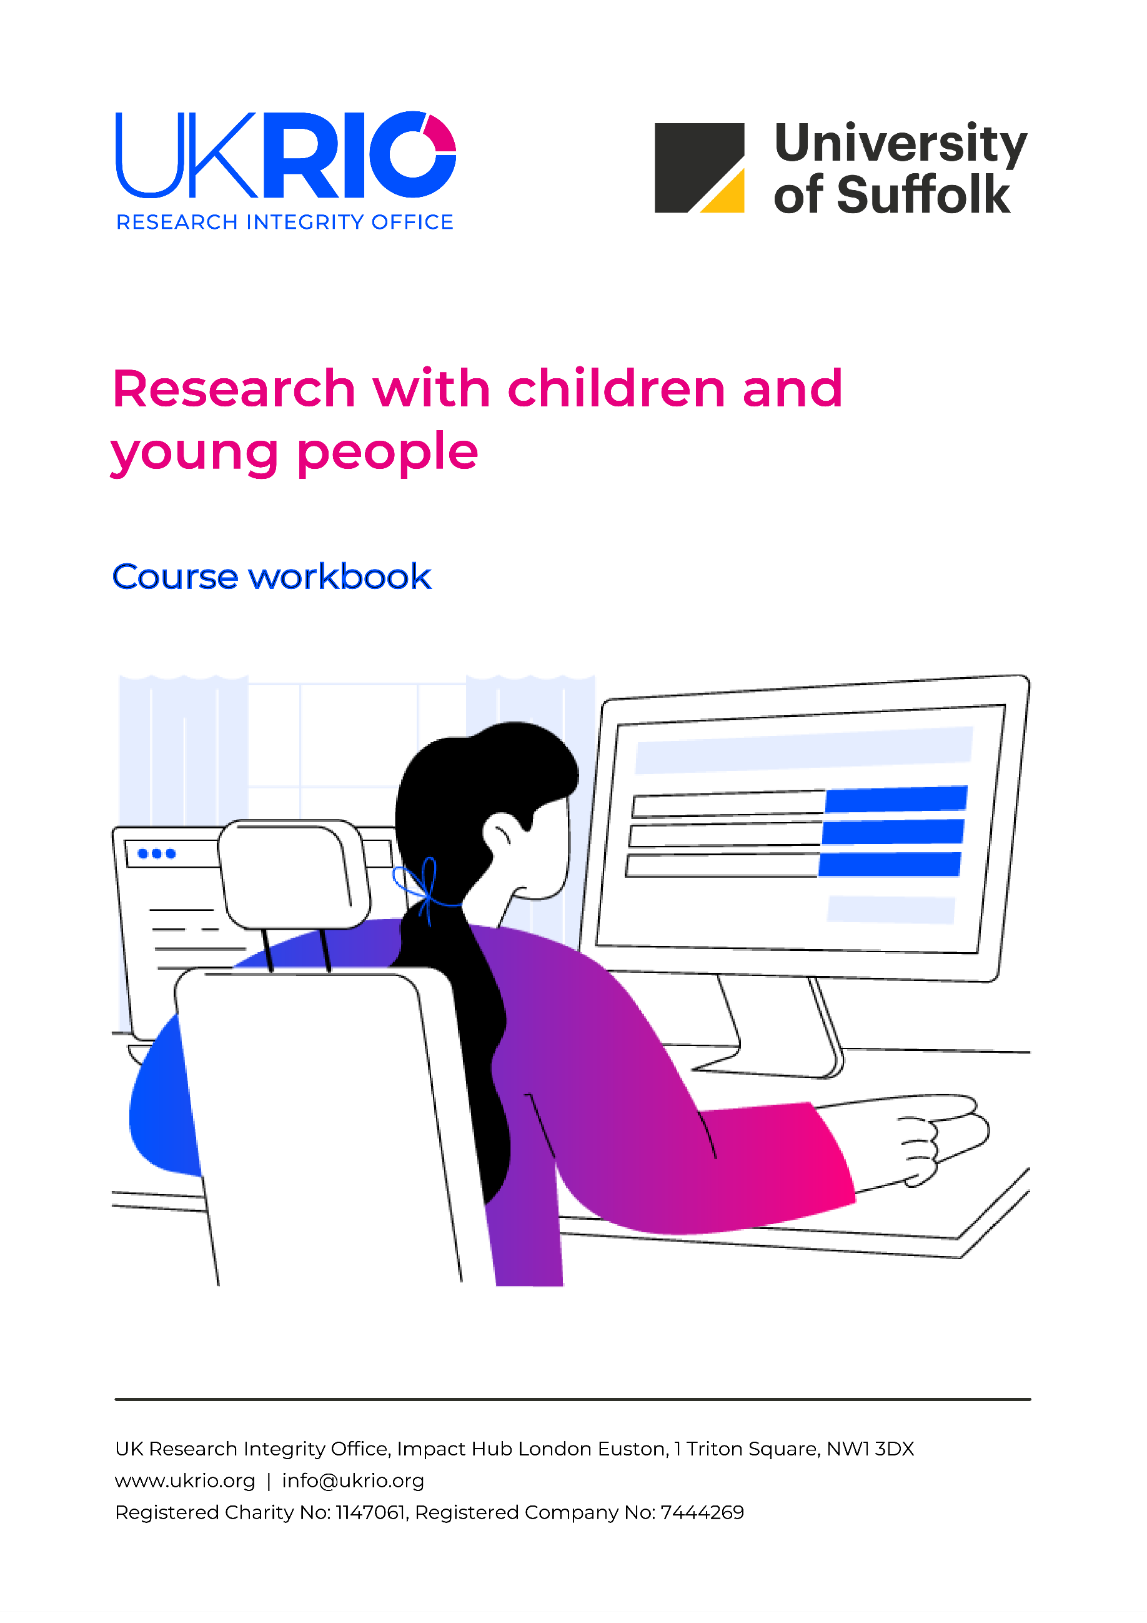



About UKRIO 1
The course workbook 2
Research with children and young people 3
Learning objectives 3
LO1: Explain the legal definitions of ‘child’ and ‘young person’ and how research involving them has changed over time 3
Further reading and resources 3
LO2: Identify key ethical principles in research with children and understand what they mean in practice 4
Further reading and resources 4
LO3: Describe the concepts of consent, assent, and dissent and how they apply when researching children 5
Further reading and resources 5
LO4: Understand what participatory research is and why it is often used with children to ensure their voices are heard 5
Further reading and resources 5
LO5: Recognise important considerations when using digital or online tools to conduct research with children 6
Further reading and resources related to this course 6
More from UKRIO 10
Explore our services 10
Stay connected 10

The UK Research Integrity Office (UKRIO) is an independent charity established in 2006. UKRIO’s vision is that through our activities, the UK research community is supported to produce work of the highest integrity, quality, and efficacy.
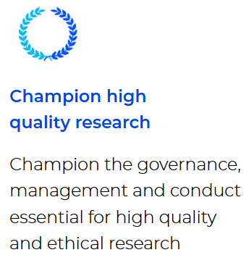
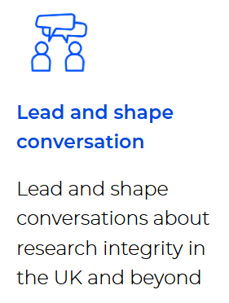
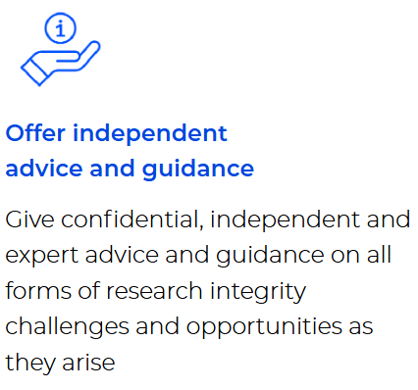
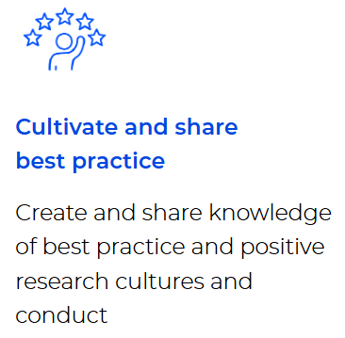
- Advisory Service: https://ukrio.org/our-work/get-advice-from-ukrio/
- Expert webinar series: https://ukrio.org/events/expert-webinar-series/
- Resources: https://ukrio.org/resources/
- Subscribers: https://ukrio.org/our-work/our-subscribers/


About UKRIO

The course workbook



This is your private course workbook for UKRIO’s online training course, Research with children and young people.
Save this document on your personal device – this document will not be shared online, and other learners cannot access your workbook. Use this workbook to type your notes and answers to the reflective questions in the course. To help you organise your notes, the activities are replicated here for each learning objective. All further reading and resources for each learning objective are also included in this document.
Disclaimer on external resources and third-party content
This course includes references and links (including hyperlinks) to external resources, tools, and materials intended to support researchers in understanding research ethics. These signposted resources are provided for convenience and are not intended to be comprehensive.
Please note that not all references are open access. Inclusion of any external link or reference does not imply endorsement or approval by UKRIO of the linked website, its operator, or its content. UKRIO is not responsible for the accuracy, content, or quality of third-party materials, nor for any websites outside of www.ukrio.org.
Researchers are encouraged to exercise professional judgement when engaging with external resources and the content provided within this course. It is important to assess the relevance, reliability, and suitability of each resource and piece of content within the context of their specific research. The information presented here is intended for educational purposes only and should not be considered a substitute for legal advice from appropriately qualified professionals. UKRIO accepts no liability for any loss or damage caused or occasioned as a result of the information provided.

Research with children and young people
The focus of this course is on conducting research with children, rather than on or for them, and understanding the ethical responsibilities that this involves. Throughout the course, learners will explore the legal definitions of children and young people, key ethical principles in practice, and the application of consent, assent, and dissent.
The course will also cover participatory approaches that give children a meaningful voice, important considerations for online and digital research, and ongoing ethical debates in the field. By the end, learners will be equipped to conduct research with children that is respectful, inclusive, and ethically responsible, recognising children as competent, active participants.

Learning objectives
- LO1: Explain the legal definitions of ‘child’ and ‘young person’ and how research
involving them has changed over time
- LO2: Identify key ethical principles in research with children and understand what they
mean in practice
- LO3: Describe the concepts of consent, assent, and dissent and how they apply when
researching children
- LO4: Understand what participatory research is and why it is often used with children
to ensure their voices are heard
- LO5: Recognise important considerations when using digital or online tools to conduct
research with children
- LO6: Be aware of some of the key ongoing ethical debates and challenges in research
with children

LO1: Explain the legal definitions of ‘child’ and ‘young person’ and how research involving them has changed over time

Further reading and resources
Children and the law:
- NSPCC Learning. Children and the law: https://learning.nspcc.org.uk/child-protection-system/children-the-law#skip-to-content

Convention on the Rights of the Child:
- United Nations. Convention on the Rights of the Child: https://www.ohchr.org/en/instruments-mechanisms/instruments/convention-rights-child
Childism:
- Childism Institute. What is childism?: https://www.childism.org/resources
- The European Parliament and the Council of the European Union: https://eur-lex.europa.eu/LexUriServ/LexUriServ.do?uri=OJ:L:2001:121:0034:0044:en:PDF
The Strange Situation Procedure:
- Van Rosmalen, L., Van der Veer, R. and Van der Horst, F. (2015). Ainsworth's Strange Situation Procedure: The origin of an instrument. J. Hist. Behav. Sci., 51: 261-284: https://doi.org/10.1002/jhbs.21729
- Van IJzendoorn, Marinus H., and Pieter M. Kroonenberg. (1988). Cross-Cultural Patterns of Attachment: A Meta-Analysis of the Strange Situation. Child Development, 59:147–56. JSTOR:
https://www.jstor.org/stable/1130396?origin=crossref

LO2: Identify key ethical principles in research with children and understand what they mean in practice

Further reading and resources
Beauchamp and Childress Principles:
- Beauchamp TL, Childress JF. (1979). Principles of biomedical ethics. New York: Oxford University Press: https://www.allisonkrilethornton.com/wp-content/uploads/Medical_Ethics_Readings/BandC-Moral-Dilemmas.pdf
Ethical research involving children:
- Ethical Research Involving Children. International Charter for Ethical Research Involving Children: https://childethics.com/ethical-standards/
- Ethical Research Involving Children. Ethical Research Involving Children (ERIC) Library: https://childethics.com/child-ethics-library/
- National Centre for Research Methods (NCRM). The Ethics of Research Involving Children: Common Questions, Potential Strategies and Useful Guidance: https://www.ncrm.ac.uk/resources/ethics/
- Qvortrup, J. (2004). The waiting child. Childhood, 11:267-273. https://doi.org/10.1177/0907568204044884

LO3: Describe the concepts of consent, assent, and dissent and how they apply when researching children

Further reading and resources
Guidance on ethical research:
- British Educational Research Association (BERA). Ethical Guidelines for Educational Research, fifth edition (2024): https://www.bera.ac.uk/publication/ethical-guidelines-for-educational-research-fifth-edition-2024
- British Sociological Association. Guidelines on Ethical Research: https://www.britsoc.co.uk/ethics
- Ethical Research Involving Children. Informed consent: https://childethics.com/informed-consent/#1638253842163-b9101865-769c
- Health Research Authority (HRA). Research involving children: https://www.hra.nhs.uk/planning-and-improving-research/policies-standards-legislation/research-involving-children/
Gillick competence:
- Griffith, R. (2016). What is Gillick competence? Human Vaccines & Immunotherapeutics, 12:244–247: https://doi.org/10.1080/21645515.2015.1091548
- National Society for the Prevention of Cruelty to Children (NSPCC). Gillick competency and Fraser guidelines: https://learning.nspcc.org.uk/child-protection-system/gillick-competence-fraser-guidelines

More information about consent, assent, and dissent – alongside wider ethical principles and considerations – can be found at:
- Alderson, P., and Morrow, V. (2011). The ethics of research with children and young people: A practical handbook, pp 127-160, identify key components involved in ethical concepts of consent, assent and dissent: https://doi.org/10.4135/9781529682694

LO4: Understand what participatory research is and why it is often used with children to ensure their voices are heard

Further reading and resources
Participatory research with children:
- Angelöw, A., & Psouni, E. (2025). Participatory Research With Children: From Child-Rights Based Principles to Practical Guidelines for Meaningful and Ethical Participation. International Journal of Qualitative Methods, 24: https://doi.org/10.1177/16094069251315391
- Sevón, E., Mustola, M., Siippainen, A., & Vlasov, J. (2023). Participatory research methods with young children: a systematic literature review. Educational Review, 77(3), 1000–1018. https://doi.org/10.1080/00131911.2023.2215465
- The European Young Persons Advisory Group Network (eYPAGnet). What is a Young Persons Advisory Group (YPAG)?: https://eypagnet.eu/toolkit/understanding/what-is-a-ypag/
Children’s participation:
- Hart, Roger. (1992). Children's Participation: From Tokenism To Citizenship. Innocenti Essays. 4: https://www.researchgate.net/publication/24139916_Children's_Participation_From_Tokenism_To_Citizenship
Young people and ethics:
- Association for Young People’s Health. (2021). How to manage research and participation projects: The ethics according to young people: https://irp-cdn.multiscreensite.com/29f8e96e/files/uploaded/Ethics%20in%20YP%20participation%20and%20research%20CommonRoom.pdf
- Nuffield Council on Bioethics. (2015). Children and clinical research: ethical issues: https://cdn.nuffieldbioethics.org/wp-content/uploads/Children-and-clinical-research.pdf

LO5: Recognise important considerations when using digital or online tools to conduct research with children

Further reading and resources related to this course
(Please note that not all resources are available as open access and some are books):
- Ainsworth, M.D.S., Blehar, M.C. & Waters, E. (2015) Patterns of Attachment: A Psychological Study of the Strange Situation. London: Taylor and Francis. https://mindsplain.com/wp-content/uploads/2021/01/Ainsworth-Patterns-of-Attachment.pdf
- Alanen, L. (1988) “Rethinking Childhood”, Acta Sociologica, 31(1): 53–67. https://www.jstor.org/stable/4200684
- Alderson, P. (1995) Listening to Children: Children, Ethics and Social Research. Ilford: Barnardo's. https://archive.org/details/listeningtochild0000alde
- Alderson, P. and Morrow, V. (2011) The ethics of research with children and young people: A practical handbook. Second edition. Los Angeles: SAGE. https://doi.org/10.4135/9781529682694
- Balagopalan, S. (2019) ‘Afterschool and during vacations’: On labor and schooling in the postcolony. Children's Geographies, 17(2): 231-245. https://doi.org/10.1080/14733285.2018.1490008
- Balagopalan, S. (2011). Introduction: Children’s lives and the Indian context. Childhood, 18(3): 291–297. https://doi.org/10.1177/0907568211413369
- Biswas, T. & Wall, J. (2023) ‘Childist theory in the humanities and social sciences’, Children & Society, 37(4):1001-1004. https://doi.org/10.1111/chso.12738
- Burman, E. (2019) Child as method: implications for decolonising educational research, International Studies in Sociology of Education, 28:1, 4-26. https://doi.org/10.1080/09620214.2017.1412266
- Burns, T. & Gottshalk (2020) Educational Research and Innovation Education in the Digital Age Healthy and Happy Children. Paris: OECD Publishing. https://www.oecd.org/content/dam/oecd/en/publications/reports/2020/10/education-in-the-digital-age_49057de2/1209166a-en.pdf
- Butler-Sloss, E. (1988). Report of the Inquiry into Child Abuse in Cleveland 1987. London: HMSO. https://discovery.nationalarchives.gov.uk/details/r/C17095254
- Cheney, K. S. (2018) ‘Decolonising Childhood Studies’, In Spyrou, R. Rosen, & D. T. Cook (eds), Reimagining Childhood Studies, pp. 99-104. London: Bloomsbury Publishing Plc. https://books.google.co.uk/books?id=eQF2DwAAQBAJ&printsec=frontcover&source=gbs_ge_summary_r&cad=0#v=onepage&q&f=false
- Christensen, P. and James, A. (2017) Research with Children: Perspectives and Practices. 3rd ed. Florence, London, New York: Routledge. ISBN 9780415416832 https://api.taylorfrancis.com/content/books/mono/download?identifierName=doi&identifierValue=10.4324/9780203964576&type=googlepdf
- Clark, A, Flewitt, R, Hammersley, M, & Robb, M (eds) 2013, Understanding Research with Children and Young People, SAGE Publications, Limited, London. ISBN: 9781446274934
- Clark, A. and Moss, P. (2017) Listening to young Children: a guide to understanding and using the Mosaic approach. Expanded third edition. London: Jessica Kingsley. https://books.google.co.uk/books?id=PCvLDQAAQBAJ&printsec=frontcover&source=gbs_ge_summary_r&cad=0#v=onepage&q&f=false
- Richards, S. and Coombs, S. (eds.) (2023) Critical perspectives on research with children: reflexivity, methodology, and researcher identity. Bristol: Bristol University Press https://doi.org/10.1332/policypress/9781529216776.001.0001
- Corsaro W (1997/2004) The Sociology of Childhood. Thousand Oaks, CA: Pine Forge Press. https://books.google.co.uk/books?hl=en&lr=&id=M0ThEAAAQBAJ&oi=fnd&pg=PA1971&dq=Corsaro+W+(1997/2004)+The+Sociology+of+Childhood.+Thousand+Oaks,+CA:+Pine+Forge+Press.&ots=ZlL53Bne3M&sig=c0BrEY-HfUsz3C12rlnv_Jlu9eY#v=onepage&q&f=false
- Groundwater-Smith, S, Dockett, S, & Bottrell, D 2014, Participatory Research with Children and Young People, SAGE Publications, Limited, London. https://doi.org/10.4135/9781473910751
- Hart, R. (1997) Children’s Participation: The Theory and Practice of Involving Young Citizens in Community Development and Environmental Care. London: Earthscan. ISBN 9781853833229
- Hokke, S. et al. (2018) “Ethical issues in using the internet to engage participants in family and child research: A scoping review,” PLoS ONE, 13(9). https://doi.org/10.1371/journal.pone.0204572
- Horton, J., & Kraftl, P. (2018). Three playgrounds: Researching the multiple geographies of children’s outdoor play. Environment and Planning A: Economy and Space, 50(1), 214-235. https://dx.doi.org/10.1177/0308518X17735324
- James, A., Jenks, C. and Prout, A. (1998) Theorizing Childhood. Cambridge: Polity Press. ISBN: 0807737305
- James, A. and Prout, A. (eds) (1990/1997) Constructing and Reconstructing Childhood: Contemporary Issues in the Sociological Study of Childhood, London: Falmer Press. https://doi.org/10.4324/9780203362600
- Jenks, C. (1990/1996). Childhood. Routledge: London https://books.google.co.uk/books?id=-A0HEAAAQBAJ&printsec=frontcover&source=gbs_ge_summary_r&cad=0#v=onepage&q&f=false
- Liamputtong, P 2010, Performing Qualitative Cross-Cultural Research, Cambridge University Press, Cambridge. https://doi.org/10.1017/CBO9780511812705
- Livingstone, S.M. and Haddon, L. (eds.) (2009) Kids online: opportunities and risks for children. Bristol: Policy Press. https://eprints.lse.ac.uk/30130/1/Kids_online_introduction_%28LSERO%29.pdf
- Mayall, B. (1994) Children’s childhoods: observed and experienced. London: Falmer Press.
- McLaughlin, H. (Ed.) (2015) Involving Children and Young People in Policy, Practice and Research. London: National Children’s Bureau.
- Montgomery, H. (2007) “Working With Child Prostitutes in Thailand: Problems of practice and interpretation,” Childhood, 14(4), pp. 415–430. https://dx.doi.org/10.1177/0907568207081849
- Niewenhuys, O. (2008). ‘The ethics of children’s rights.’ Childhood, 15(1): 4–11.
- OECD (2019) “Impacts of technology use on children: Exploring literature on the brain, cognition and wellbeing”. OECD Education Working Papers No. 195. Paris: OECD Publishing. https://doi.org/10.1787/8296464e-en
- Punch, S. (2016) “Cross-world and cross-disciplinary dialogue: A more integrated, global approach to childhood studies,” Global Studies of Childhood, 6(3), pp. 352–364. https://doi.org/10.1177/2043610616665033
- Punch, S., & Tisdall, E. K. M. (2013). Children and young people’s relationships: Learning across majority and minority worlds. London: Routledge. ISBN 9781032930688
- Punch, S. (2002) ‘Research with children: the same or different from research with adults?’ Childhood, 9:3, 321– 341. https://doi.org/10.1177/0907568202009003005
- Qvortrup, J. (2004) The waiting child. Childhood, 11(3):267–273. https://doi.org/10.1177/0907568204044884
- Qvortrup, J., Bardy, M., Sgritta, G. & Wintersberger, H. (eds) (1994). Childhood Matters: An Introduction. In Childhood Matters: Social Theory, Practice and Politics. Avebury Press: Aldershot. https://archive.org/details/childhoodmatters0000unse
- Richards, S. and Coombs, S. (eds.) (2023) Critical perspectives on research with children: reflexivity, methodology, and researcher identity. Bristol: Bristol University Press. https://doi.org/10.1332/policypress/9781529216776.001.0001
- Sandin, B, Josefsson, J, Hanson, K, & Balagopalan, S (eds) 2023, The Politics of Children's Rights and Representation, Springer International Publishing AG, Cham. https://library.oapen.org/handle/20.500.12657/61843
- Sinha, P. (2017) “Listening ethically to indigenous children: experiences from India,” International Journal of Inclusive Education, 21(3): 272–285. https://doi.org/10.1080/13603116.2016.1260843
- Spyrou, S., Rosen, R. & Cook, D. T. (eds), (2018) Reimagining Childhood Studies. London: Bloomsbury Publishing Plc. https://doi.org/10.5040/9781350019256
- Uprichard, E. (2008) Children as ‘Being and Becomings’: Children, Childhood and Temporality. Children & Society, 22: 303–313. https://doi.org/10.1111/j.1099-0860.2007.00110.x
- Valentine, G. (1999) Being seen and heard? The Ethical complexities of working with children and young people at home and at school, Ethics, Place and Environment, 2:2, 141-155. https://doi.org/10.1080/13668799908573667
- Veale, A. (2005) ‘Creative Methodologies in Participatory Research with Children’ in Greene, S. & Hogan, D. (eds) Researching Children’s Experience: Approaches and Methods. London: Sage. https://doi.org/10.4135/9781849209823.n14
- Waksler, F. C. 1986. Studying Children: Phenomenological Insights. Human Studies 8 (1),71-82. https://www.jstor.org/stable/20008957
- Young-Bruehl, E. (2012) Childism: confronting prejudice against children. Yale University Press. https://books.google.co.uk/books?id=WunZB-bcLgMC&printsec=frontcover&source=gbs_ge_summary_r&cad=0#v=onepage&q&f=false

More from UKRIO


Thank you for taking Research with children and young people online training course. We hope the insights gained from this course will support you in strengthening your work and contributing to more ethical research.
We encourage you to visit our channels to learn more about our work, how it can support you in upholding high standards of research integrity, and how you can get involved.

Explore our services
- Advisory Service
- Events and training
- Resources
- Subscriptions

Stay connected
- Newsletter
- Website
- LinkedIn
- YouTube

